Multiple-choice section – choose the correct answer

Question 1 [2.6] [10A]­­­

A sample of test scores from classes 10A and 10B are shown below. The differences between the means and the interquartile ranges, respectively, from the data sets are:

10A: 75, 59, 86

10B: 53, 74, 62

A 75, 62 B 74, 62 C 73.3, 63 D 73, 62

Question 2 [2.3]

The following graph shows the temperature as recorded every hour for a number of hours from noon.

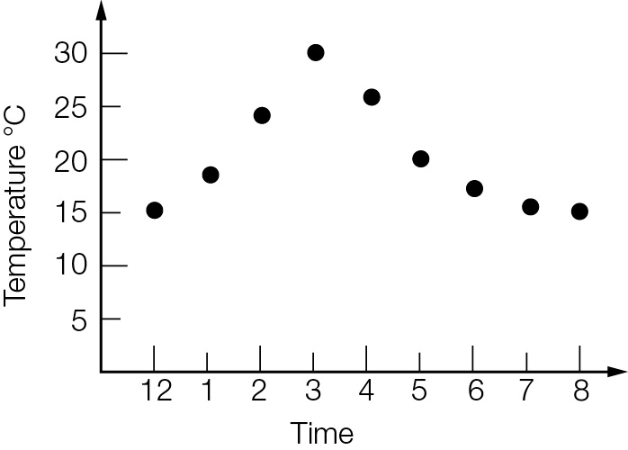

Which of the following statements is *incorrect*?

A The minimum temperature recorded was 15 °C.

B The minimum temperature reached on the day was 15 °C.

C The maximum temperature recorded on the day was 30 °C.

D The temperature rose quicker in the early afternoon than it fell in the late afternoon/evening.

Question 3 [2.5]

Which box plot represents the following data set?

1, 2, 2, 2, 3, 4, 5, 6, 6

|  |  |
| --- | --- |
| **A**  PM10_PR_TSa_7_02 | **B**  PM10_PR_TSa_7_03 |
| **C**  PM10_PR_TSa_7_04 | **D**  PM10_PR_TSa_7_05 |

Question 4 [2.4]

The relationship betweenandfor the scatter graph shown below can be best described as:

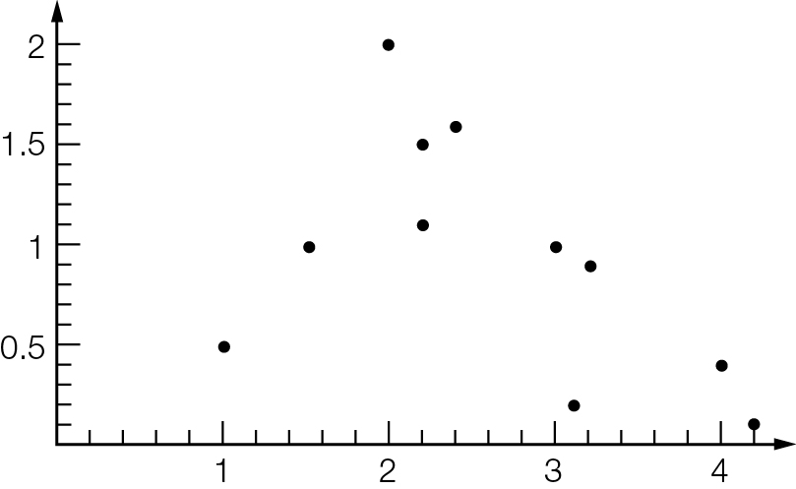

**A** perfect negative linear relationship

**B** strong negative linear relationship

**C** no linear relationship

**D** weak positive linear relationship

Question 5 [2.2]

Which of the graphs below correctly shows two outliers:

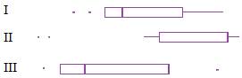

**A** II only **B** I and II only

**C** all three **D** none

Question 6 [2.2]

For the data set represented in the cumulative frequency graph, 60% of the data lies below what approximate value?

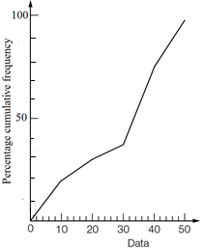

A 60 B 54 C 40 D 36

Question 7 [2.2]

The interquartile range of the data set is:

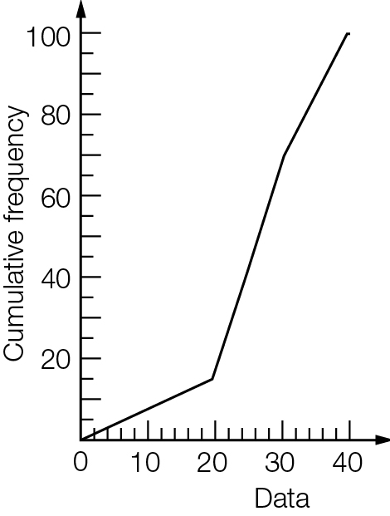

A 10 B 22 C 27 D 32

Question 8 [2.2]

The five-number summary (minimum value, lower quartile, median, upper quartile, maximum value) of a particular data set is shown below.  
 19, 23, 42, 51, 68  
Which of the following statements about the data is *untrue*?

**A** the data set contains no outliers

**B** about 25% of the values lie below 51

**C** the interquartile range is 28

**D** about 50% of the values lie below 42

Question 9 [2.8] [10A]­­­

The mean and standard deviation, respectively, for the following data, appropriately rounded is:

4.2, 9.5, 6.3, 2.4, 0.7

**A** 4.6, 3.43 **B** 4.7, 3.07 **C** 4.7, 3.40 **D** 4.6, 3.07

Multiple-choice results: \_\_\_ / 9

Short answer section

Question 10 3 marks [2.1–2.7]

Choose from the following words and expressions to complete the sentences below.

*bivariate dependent independent mean primary secondary univariate*

**(a)** \_\_\_\_\_\_\_\_\_\_\_\_\_\_\_ data is described using two variables.

**(b)** \_\_\_\_\_\_\_\_\_\_\_\_\_ data is data collected by yourself and \_\_\_\_\_\_\_\_\_\_\_\_\_\_ data is data collected by someone else.

Question 11 10 marks [2.1, 2.3]

For the two sets of data below:

**(i)** Write the five-number summary.

**(ii)** Calculate the mean.

**(a)** 24, 13, 15, 2, 18, 7, 6, 15, 4, 4

**(b)**

|  |  |
| --- | --- |
| *x* | *f* |
| 56 | 3 |
| 57 | 2 |
| 58 | 12 |
| 59 | 20 |
| 60 | 15 |

Question 12 5 marks [2.3]

(a) For each data set find the (i) median (ii) range and (iii) interquartile range.

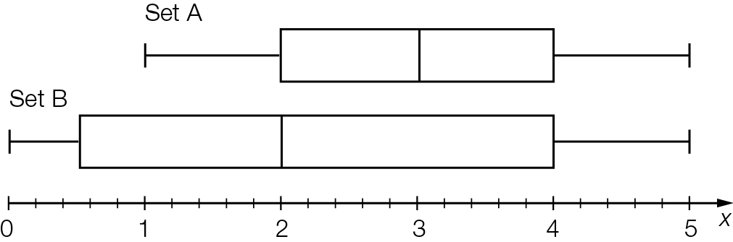

(b) Compare the statistics for the two data sets.

Question 13 3 marks [2.5]

The share price for a volatile stock was recorded each hour for a 5 hour period.

|  |  |  |  |  |  |  |
| --- | --- | --- | --- | --- | --- | --- |
| Time | 1 pm | 2 pm | 3 pm | 4 pm | 5 pm | 6 pm |
| Price | $1.20 | $2.40 | $2.50 | $1.10 | $1 | $1.30 |

(a) Draw a scatter plot of the price of the stock on the graph below.

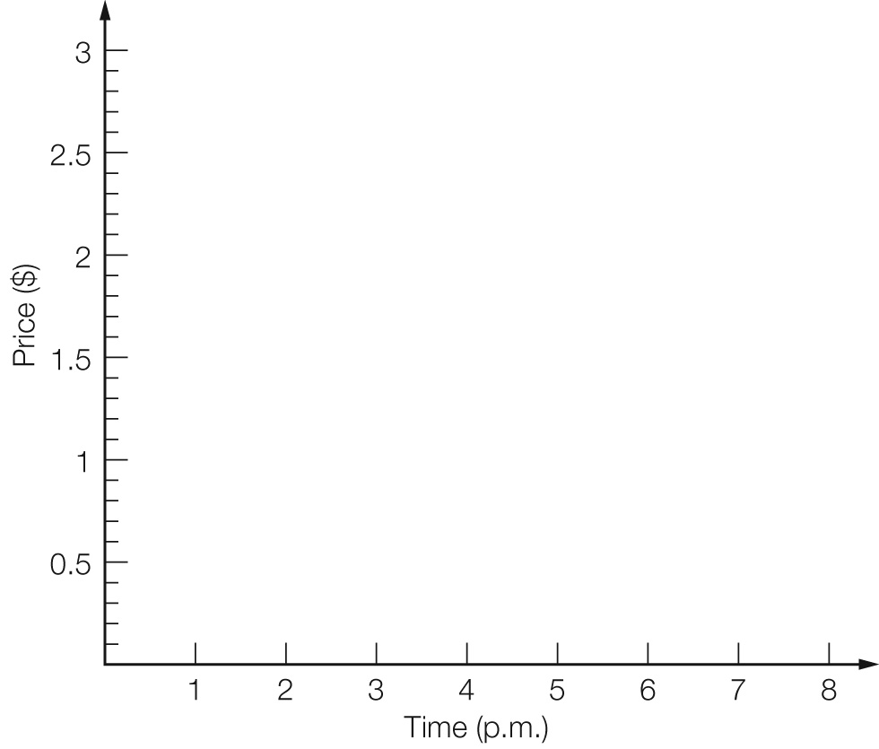

(b) Describe the price movement of the stock over the 5 hour time period.

Question 14 10 marks [2.2]

The following data are the years of death of 26 people buried in a section of a cemetery.

1955, 1944, 1934, 1908, 1955, 1866, 1934, 1945, 1945, 1961, 1944, 1947, 1956,  
1866, 1866, 1954, 1954, 1974, 1942, 1938, 1931, 1950, 1963, 1968, 1953, 1963

(a) Find the mean and median of the data. Write the mean in whole years.

(b) Draw a box plot of the data.

Question 15 5 marks [2.7]

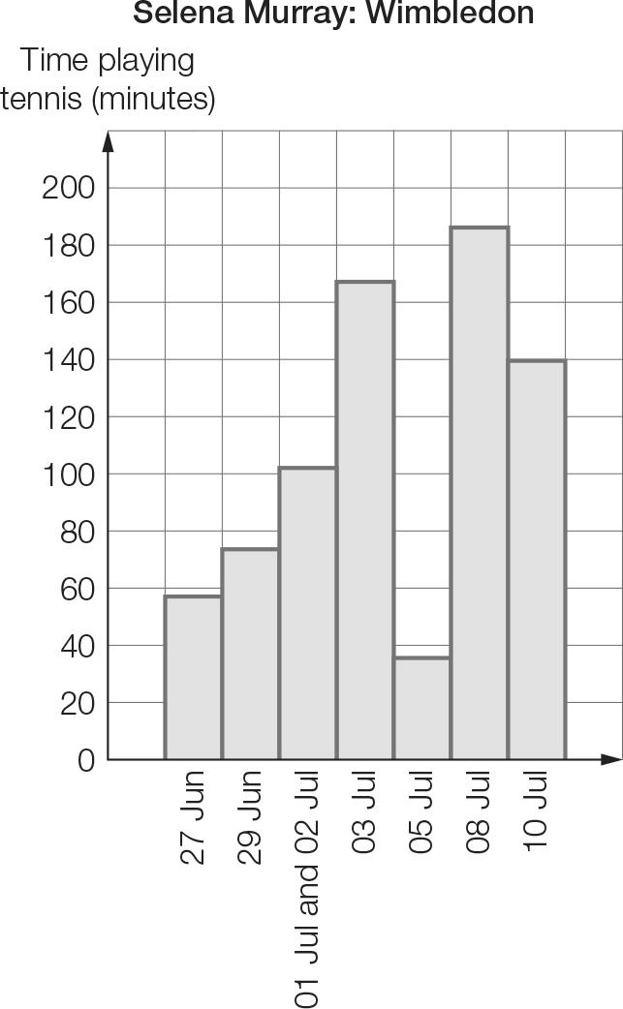

**(a)** What is unusual about the values at the base of the bars on the horizontal axis?

**(b)** In which tennis matches did Selena play for the longest and shortest time periods? (Each bar on the graph represents one tennis match.)

**(c)** Why does the third bar have two dates? Suggest a possible reason.

**(d)** Calculate the average amount of time per match.

Short answer results: \_\_\_ / 36

Extended answer section

Question 16 8 marks [2.1]

The frequency table below shows the weights (kg) of players in a cricket club.

|  |  |
| --- | --- |
| Weight (kg) | Frequency |
| 64−<66 | 1 |
| 66−<68 | 6 |
| 68−<70 | 10 |
| 70−<72 | 17 |
| 72−<74 | 11 |
| 74−<76 | 10 |
| 76−<78 | 6 |
| 78−<80 | 5 |

(a) Construct a cumulative frequency curve on the axes provided.

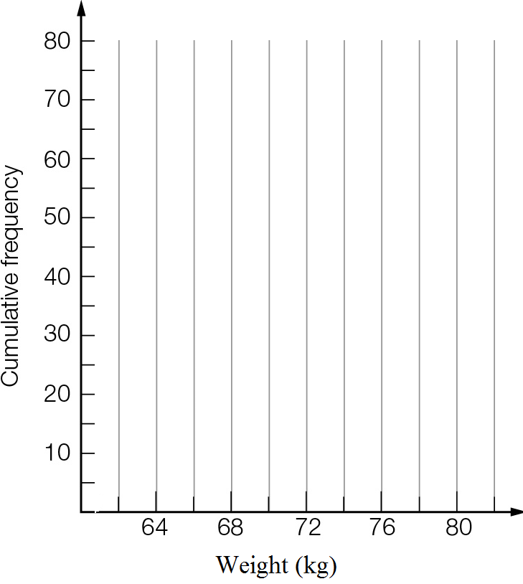

(b) Use the cumulative frequency curve to complete the five-number summary for the data.

|  |  |  |  |  |
| --- | --- | --- | --- | --- |
| Min | QL | Median | QU | Max |
|  |  |  |  |  |

(c) Draw a box plot for the data.

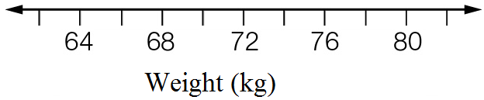

Question 17 5 marks [2.4, 2.6] [10A]­­­

Below are the scores for Maths and English tests.

|  |  |  |  |  |  |  |  |  |
| --- | --- | --- | --- | --- | --- | --- | --- | --- |
| English | 28 | 50 | 25 | 27 | 42 | 38 | 40 | 22 |
| Maths | 48 | 50 | 32 | 36 | 48 | 44 | 42 | 47 |

Considering ‘English mark’ as the independent variable:

(a) Use a calculator to find a relationship between the marks in the form y = mx + c. Round the values of m and c correct to 2 decimal places.

(b) Sketch the calculator-drawn graph of the data.

(c) Write the relationship using the variables ‘Maths mark’ and ‘English mark’.

(d) Use the relationship to estimate the Maths mark for a student who scored 34 for English.

Question 18 10 marks [2.1, 2.3]

The data below gives the average monthly minimum daily temperatures (in °C) of two Australian cities. The months are in order: January to December.

City X: 12, 12, 11, 9.1, 7.1, 5.1, 4.5, 5.1, 6.4, 7.8, 9.3, 10.8

City Y: 21.2, 20.6, 17.4, 12.5, 8.2, 5.1, 4, 5.9, 9.7, 14.8, 17.9, 20.2

(a) Find the five-number summary of temperatures for each city.

(b) Draw a parallel box plot for the two cities.



(c) Use the median, range and IQR to compare the temperatures for the two cities.

Question 19 7 marks [2.1, 2.3]

The following table lists the number of games won in the winter season of 10 games by the winning sports teams in a school.

|  |  |
| --- | --- |
| Games won | Number of teams |
| 1 | 3 |
| 2 | 3 |
| 3 | 6 |
| 4 | 2 |
| 5 | 4 |
| 6 | 2 |
| 7 | 3 |
| 8 | 0 |
| 9 | 1 |
| 10 | 1 |

(a) What is the mean number of games won by these winning teams?

(b) The school had a total of 30 teams playing winter sports. Calculate the mean number of wins for all teams.

Question 20 10 marks [2.3, 2.8]

The data below gives the weights of newly hatched chicks in grams.

54 63 52 54 74 65 53 57 63 60 53 54 53 54 70 57 66 60 56 64

61 57 65 54 58 65 73 67 65 72 67 52 55 52 73 71 53 67 63 55

(a) Draw a histogram of the weights. Use a class interval of 5, with the first interval being 50-<55.

(b) Construct a box plot for the weights.

(c) Draw a dot plot of the weights.

(d) What do the displays in (a) to (c) tell you about the weights of the chicks?

[10A]­­­ (e) Find the mean and standard deviation of the weights.

Extended answer results: \_\_\_ / 40

TOTAL test results: \_\_\_ / 85